



Project Name: Online Dairy World

Branch PG-DAC Mar-2023

Documentation On

**“**Online Dairy world**”**

PG-DAC March 2023

**Guided By: Snehal Somvanshi.**

Submitted By:

**Group No: 21**

* **Aditya Waikar 230343020110**
* **Supriya Bhinge 230343020014**
* **Dhruti Patil 230343020069**

**Table of Contents**

**1. Introduction 4**

1.1 Document Purpose **4**

1.2 Project Background **4**

1.3 Aim & Objectives **4**

**2. Business Requirements Overview**…………………………………………………………**5**

**3.Functional Requirements** **6**

3.1 Admin Module **6**

3.2 Buyers Module **6**

**4.** **Non-Functional Requirement………………………………………………………………7**

**5. Use Case Diagram 8**

5.1 Admin **9**

5.2 Buyer **10**

**6. Database Design 12**

1 Tourist **12**

2 Employee **12**

3 Login…………………………………………………………………………………… **13**

4 Admin **13**

5 OrderRecord **13**

6 Role **13**

7 Traveller **13**

8 Address **13**

9 PackageImages **14**

10 Package **14**

11 PlannedTour **14**

12 Transaction………………………………………………………………………………………**15**

13 Traveller…………………………………………………………………………………………**15**

**7. E-R Diagram………………………………………………………………………………………14**

**8. Snapshots 15**

**9. Conclusion 20**

**List of Figures**

**Use Case Diagrams 17**

Fig 1 Admin 8

Fig 2 Employee 9

Fig 3 Tourist 10

Fig 4 ER Diagram 14

1. **Introduction**
   1. **Document Purpose**

The purpose of an Online Dairy World Web Application BRS (Business Requirements Specification) document is to outline the specific business requirements and functionalities of an online dairy web application. This document serves as a blueprint for the development team, guiding them in creating the application according to the desired specifications and objectives.

**1.2 Project Background**

With the rise of e-commerce and changing consumer preferences, many dairy producers are looking to establish a direct connection with their customers. An Online Dairy Web Application allows farmers and dairy businesses to sell their products directly to consumers without relying solely on traditional distribution channels. It will enable dairy businesses to transit from traditional, manual processes to digital platforms, allowing for greater automation, accuracy, and convenience.

**1.3 Goals of the project**

One of the primary goals is to provide an online platform for selling dairy products directly to customers. This allows dairy producers to expand their reach beyond traditional brick-and-mortar stores and tap into a larger customer base. It also makes it easier for customers to access a wide range of dairy products without physically visiting multiple stores. Customers can explore product catalogues, check availability, compare prices, and place orders at their convenience. This accessibility can be particularly useful for customers who have limited access to physical stores or prefer online shopping.

**2. Business Requirements Overview**

* Online Dairy World system is the public web application.
* Online Dairy World system will be opened to the India, but in the phase 1, the main target is the Maharashtra’s Pune city.
* There will be mainly 3 types of user. One is the Sweets Dealer, second one is Farmer and last one is Consumer.
* Sweet Dealers and Farmers both can add their products on the system to sell.
* Consumer can search for the products available on the system and even the information about the farmer and dealer and accordingly purchased those products.
* Online Dairy World System provides the functions which connect the farmers, Sweet dealers and consumers efficiently.
* Online Dairy World System could be maintained by Administrator.

**3. Functional Requirements Overview**

Online Dairy World System consists of four modules described as below.

1. Admin Module

# 2. Buyer Module

**Admin Module:**

* + - Admin can add, update, delete employees who will deliver the product .
    - Admin can add, update, delete suppliers.
    - Admin can browse through all products.
    - Admin can handover over delivery to delivery boy.
    - Admin will keep status of all the orders.
    - Admin will receive payment from sellers.
    - Admin can authenticate suppliers
    - Registration and creation of supplier profile
    - Add , delete, update Products.
    - Supplier will receive payment from customers.
    - Supplier will handover respective products to delivery boy.

**Buyer Module:**

* + - Creation , updation, deletion of user profile
    - Browse through all the products
    - Buyer can place order.
    - Buyer can cancel order.
    - Make payment.
    - Buyer gets notified on receiving order.
    - Buyer can give feedback about product.

**4. Non-Functional Requirements**

**4.1. Performance**: The web application should be able to handle concurrent user requests efficiently and provide a responsive user experience.

**4.2. Security**: User data, including personal information and payment details, should be securely stored and transmitted using encryption protocols.

**4.3. Usability**: The user interface should be intuitive, visually appealing, and easy to navigate, ensuring a seamless shopping experience.

**4.4. Reliability**: The application should be reliable, with minimal downtime and error handling mechanisms to handle exceptions gracefully.

**4.5. Scalability**: The application should be scalable to handle increasing user traffic and accommodate a growing number of products and orders.

**4.6. Compatibility**: The web application should be compatible with different web browsers and devices to ensure broad accessibility.

**4.7. Accessibility**: The application should be designed with accessibility features to cater to users with disabilities, adhering to accessibility standards.

**4.8. Inventory Management**: The system should include inventory management capabilities to track product availability and update stock levels in real-time.

**4.9. Performance Monitoring**: The application should have monitoring tools to track performance metrics, identify bottlenecks, and optimize system resources.

**4.10. Compliance**: The web application should comply with relevant legal and industry standards, such as data protection, privacy regulations, and online payment security guidelines.

## 5. Use-Case Diagram

**5.1 Admin:**

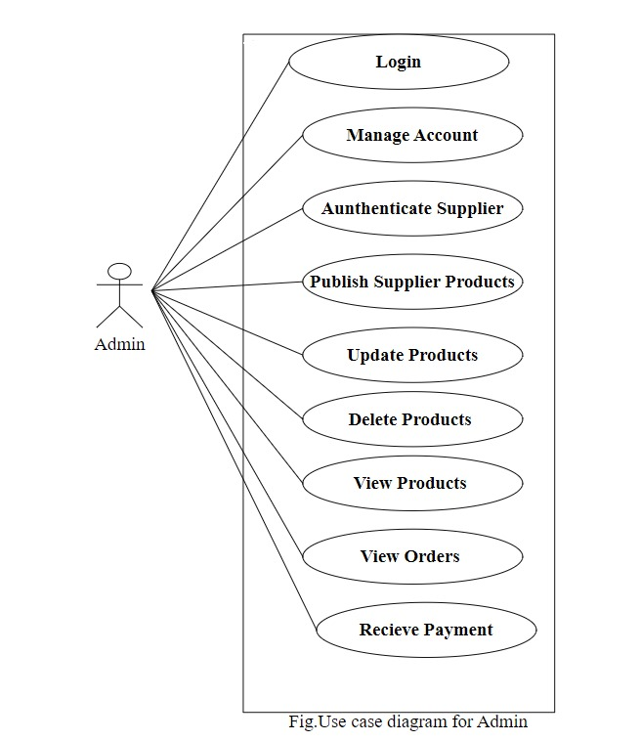

## 5.2 Buyer

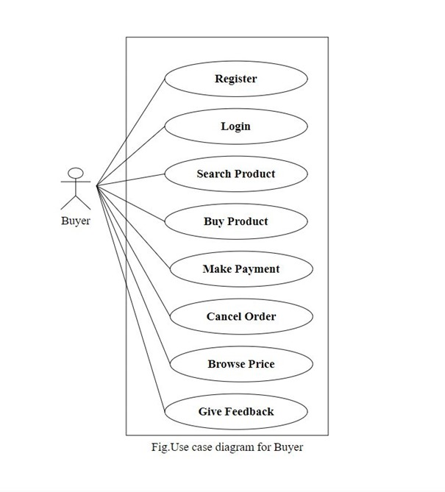

**6. Database Design:**

1. **login table**

|  |  |  |  |  |  |
| --- | --- | --- | --- | --- | --- |
| **login** | | | | | |
| Field | Type | Null | Key | Default | Extra |
|
| login_id | int | NO | PRI | NULL | auto_increment |
| uid | varchar(45) | NO |  | NULL |  |
| pwd | varchar(45) | NO |  | NULL |  |
| role_id | int | YES | MUL | NULL |  |

**2] role table**

|  |  |  |  |  |  |
| --- | --- | --- | --- | --- | --- |
| **role** | | | | | |
| Field | Type | Null | Key | Default | Extra |
|
| role_id | int | NO | PRI | NULL | auto_increment |
| role_name | varchar(45) | NO |  | NULL |  |

**3] tourist table**

|  |  |  |  |  |  |
| --- | --- | --- | --- | --- | --- |
| **tourist** | | | | | |
| Field | Type | Null | Key | Default | Extra |
|
| tourist_id | int | NO | PRI | NULL | auto_increment |
| t_fname | varchar(45) | NO |  | NULL |  |
| t_lname | varchar(45) | YES |  | NULL |  |
| t_email | varchar(45) | YES |  | NULL |  |
| t_addressid | int | YES | MUL | NULL |  |
| t_contact | varchar(45) | YES |  | NULL |  |
| t_loginid | int | YES | MUL | NULL |  |
| t_bdate | Date | YES |  | NULL |  |

**4] package table**

|  |  |  |  |  |  |
| --- | --- | --- | --- | --- | --- |
| **package** | | | | | |
| Field | Type | Null | Key | Default | Extra |
|
| package_id | int | NO | PRI | NULL | auto_increment |
| packagename | varchar(100) | YES | UNI | NULL |  |
| packageprice | decimal(9,2) | NO |  | NULL |  |
|  |  |  |  |  |  |
| duration | varchar(45) | NO |  | NULL |  |
| tourist_capacity | int | NO |  | NULL |  |
| description | longtext | NO |  | NULL |  |
| locations | varchar(100) | YES |  | NULL |  |

**5] plannedtour table**

|  |  |  |  |  |  |
| --- | --- | --- | --- | --- | --- |
| **plannedtour** | | | | | |
| Field | Type | Null | Key | Default | Extra |
|
| tour_id | int | NO | PRI | NULL | auto_increment |
| startdate | date | YES |  | NULL |  |
| lastdate | date | YES |  | NULL |  |
| availseats | int | YES |  | NULL |  |
| lastdate_apply | date | YES |  | NULL |  |
| packageid | int | YES | MUL | NULL |  |
| packageimages | mediumblob | YES |  | NULL |  |
| employeeid | int | YES | MUL | NULL |  |

**6] address table**

|  |  |  |  |  |  |
| --- | --- | --- | --- | --- | --- |
| **address** | | | | | |
| Field | Type | Null | Key | Default | Extra |
|
| address_id | int | NO | PRI | NULL | auto_increment |
| addressline | varchar(200) | YES |  | NULL |  |
| district | varchar(45) | YES |  | NULL |  |
| city | varchar(45) | YES |  | NULL |  |
| postal_code | int | YES |  | NULL |  |
| state | varchar(45) | YES |  | NULL |  |
| country | varchar(45) | YES |  | NULL |  |

**7] admin table**

|  |  |  |  |  |  |
| --- | --- | --- | --- | --- | --- |
| **admin** | | | | | |
| Field | Type | Null | Key | Default | Extra |
|
| admin_id | int | NO | PRI | NULL | auto_increment |
| a_loginid | int | YES | MUL | NULL |  |

**8] transaction table**

|  |  |  |  |  |  |
| --- | --- | --- | --- | --- | --- |
| **transaction** | | | | | |
| Field | Type | Null | Key | Default | Extra |
|
| transaction_id | int | NO | PRI | NULL | auto_increment |
| amount | decimal(9,2) | NO |  | NULL |  |
| paymentdate | datetime | YES |  | NULL |  |
| paymenttype | varchar(45) | YES |  | NULL |  |
| orderid | int | YES | MUL | NULL |  |

**9] orderrecord table**

|  |  |  |  |  |  |
| --- | --- | --- | --- | --- | --- |
| **orderrecord** | | | | | |
| Field | Type | Null | Key | Default | Extra |
|
| order_id | int | NO | PRI | NULL | auto_increment |
| touristid | int | YES | MUL | NULL |  |
| packageid | int | YES | MUL | NULL |  |
| touristnumber | int | NO |  | NULL |  |
| transactionid | int | YES |  | NULL |  |

**10] traveller table**

|  |  |  |  |  |  |
| --- | --- | --- | --- | --- | --- |
| **traveller** | | | | | |
| Field | Type | Null | Key | Default | Extra |
|
| travellerid | int | NO | PRI | NULL |  |
| fname | varchar(45) | YES |  | NULL |  |
| lname | varchar(45) | YES |  | NULL |  |
| age | int | NO |  | NULL |  |
| bdate | varchar(45) | YES |  | NULL |  |
| gender | enum('M','F') | YES |  | NULL |  |
| phoneno | varchar(45) | YES |  | NULL |  |
| addressid | int | YES | MUL | NULL |  |
| orderid | int | YES | MUL | NULL |  |

**11] employee table**

|  |  |  |  |  |  |
| --- | --- | --- | --- | --- | --- |
| **employee** | | | | | |
| Field | Type | Null | Key | Default | Extra |
|
| employee_id | int | NO | PRI | NULL | auto_increment |
| e_bdate | varchar(45) | NO |  | NULL |  |
| e_fname | varchar(45) | NO |  | NULL |  |
| e_mname | varchar(45) | YES |  | NULL |  |
| e_lname | varchar(45) | YES |  | NULL |  |
| e_gender | enum('M','F') | NO |  | NULL |  |
| e_hiredate | date | NO |  | NULL |  |
| e_designation | varchar(45) | NO |  | NULL |  |
| e_contact | varchar(45) | NO |  | NULL |  |
| e_addressid | int | YES | MUL | NULL |  |
| e_adharno | varchar(45) | YES | UNI | NULL |  |
| e_mail | varchar(45) | NO | UNI | NULL |  |
| e_photo | mediumblob | NO |  | NULL |  |
| e_loginid | int | YES | MUL | NULL |  |

**12] packageimages table**

|  |  |  |  |  |  |  |
| --- | --- | --- | --- | --- | --- | --- |
| **packageimages** | | | | | | |
| Field | Type | Null | Key | Default | Extra |  |
| packageimage_id | int | NO | PRI | NULL | auto_increment |  |
| packimage | longblob | YES |  | NULL |  |  |
| package_id | int | YES | MUL | NULL |  |  |

## ER-Diagram:

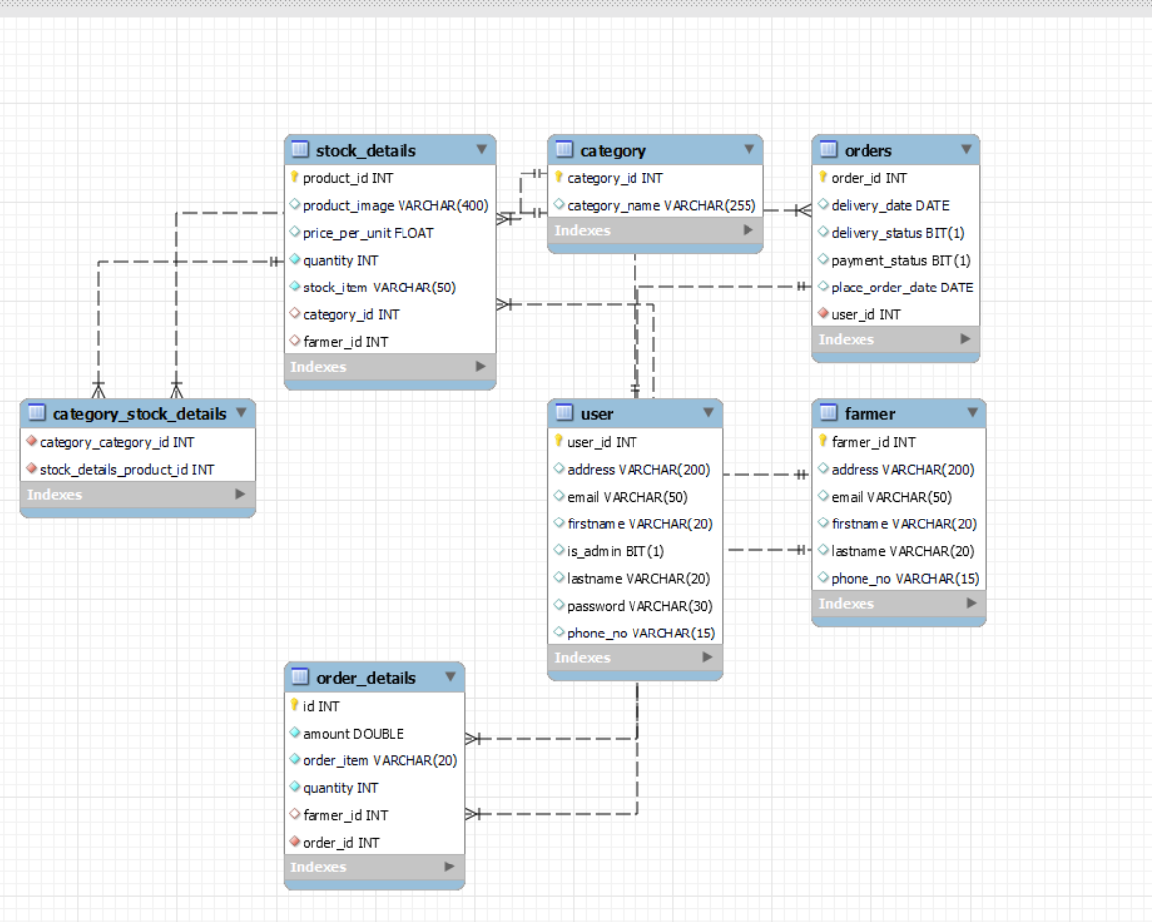

**E-R diagram shows database of Online Dairy World**

**8. Snapshots:**

**8.1 Home Page & Login Page:**

Following snapshot shows the Home page and login page.

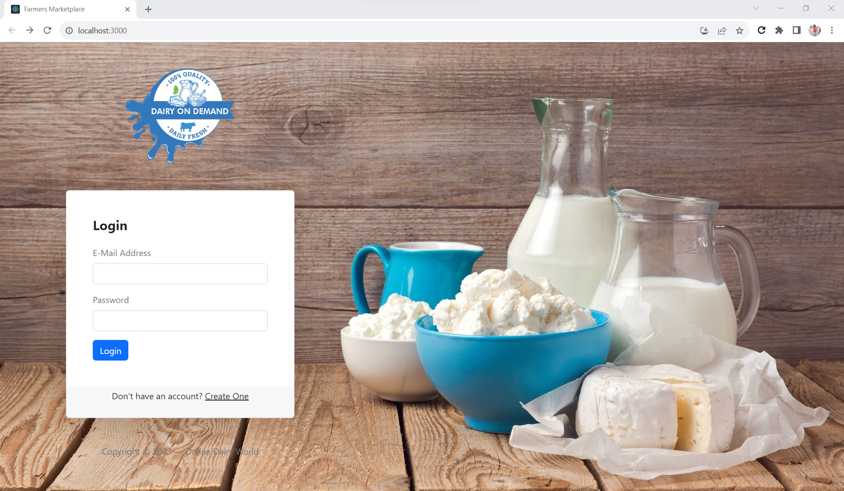

This page contains following controls

* Home
* Sign Up
* Login Button

This page also contains copyright consisting information about the website.

**8.2 Registration Page:**

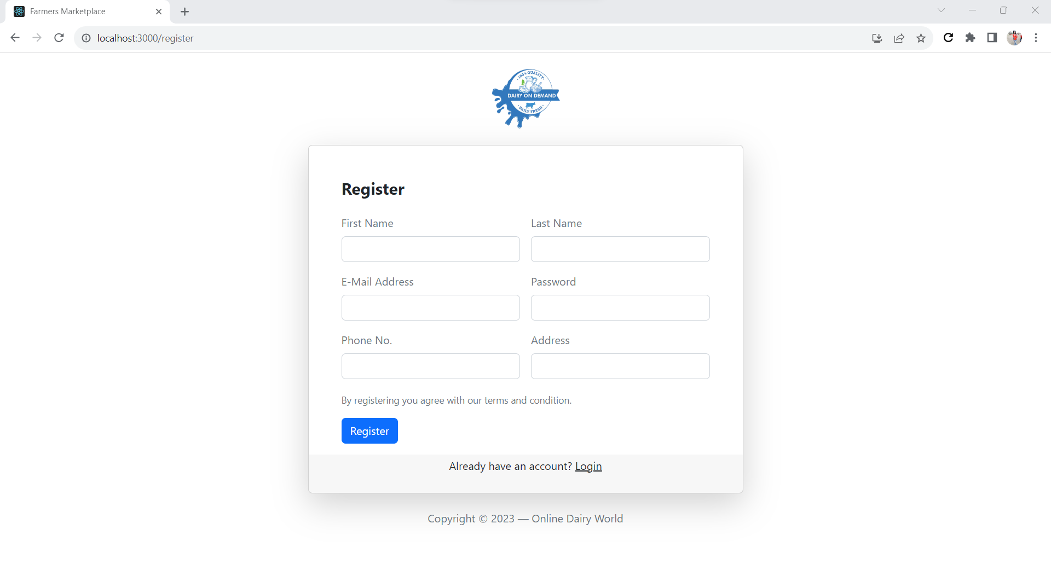

**8.3 Admin Login Page**

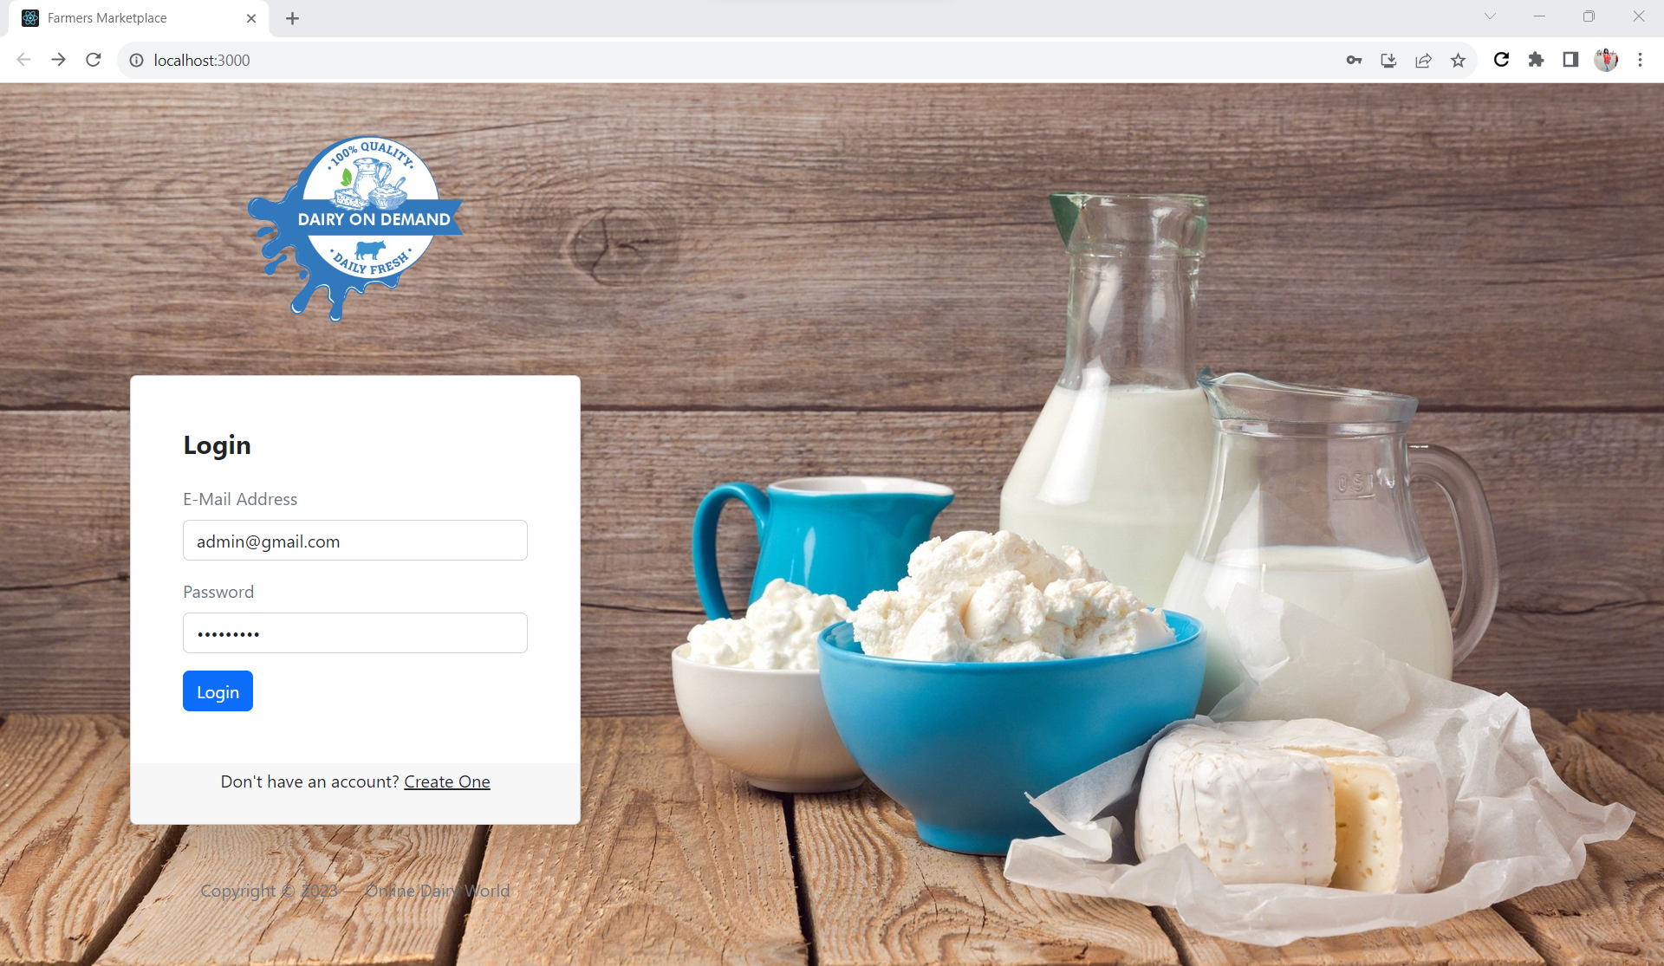

**8.3.1 Admin Home Page**

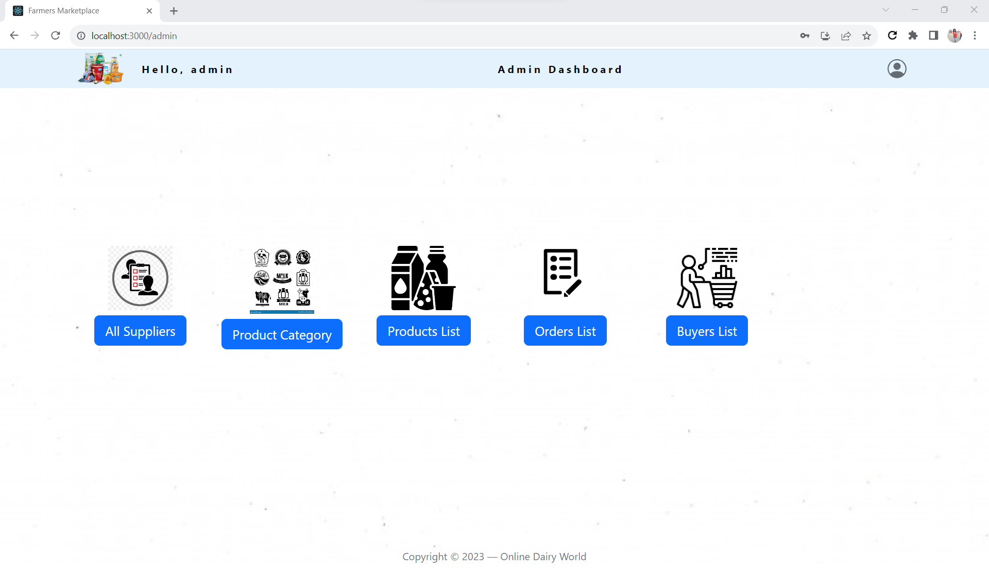

**8.3.2 List of all suppliers.**

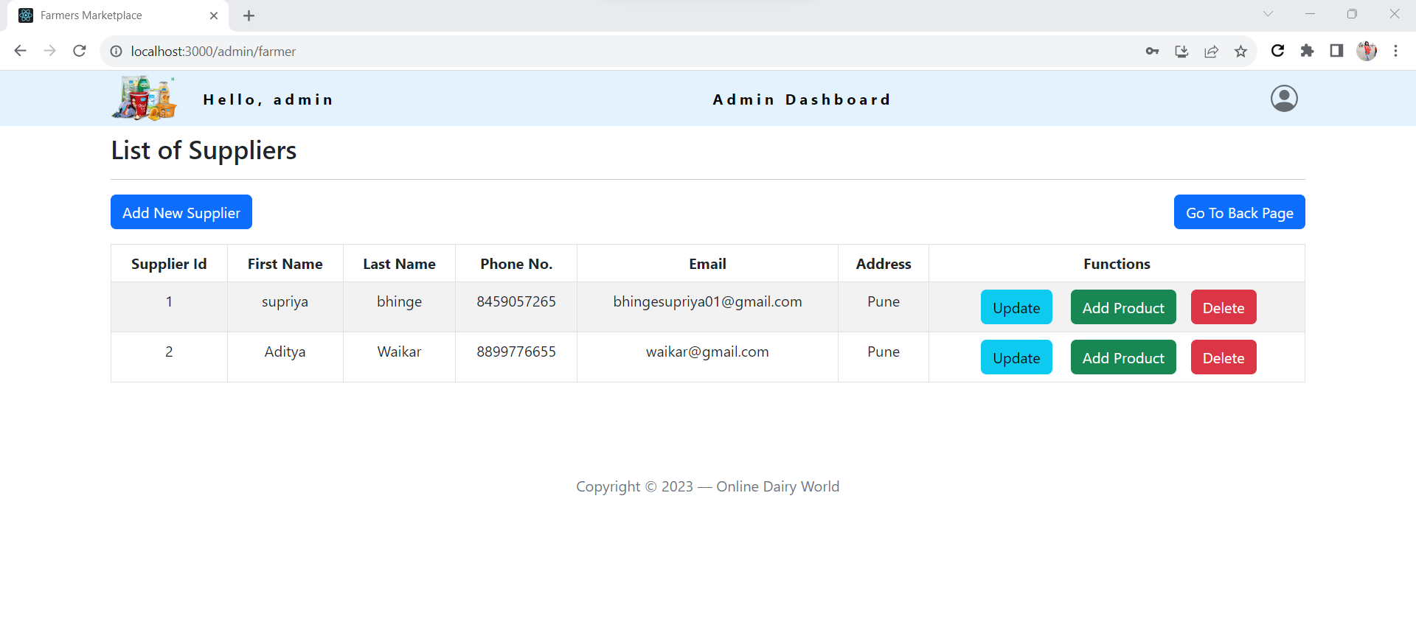

**8.3.3 Form for add new Supplier.**

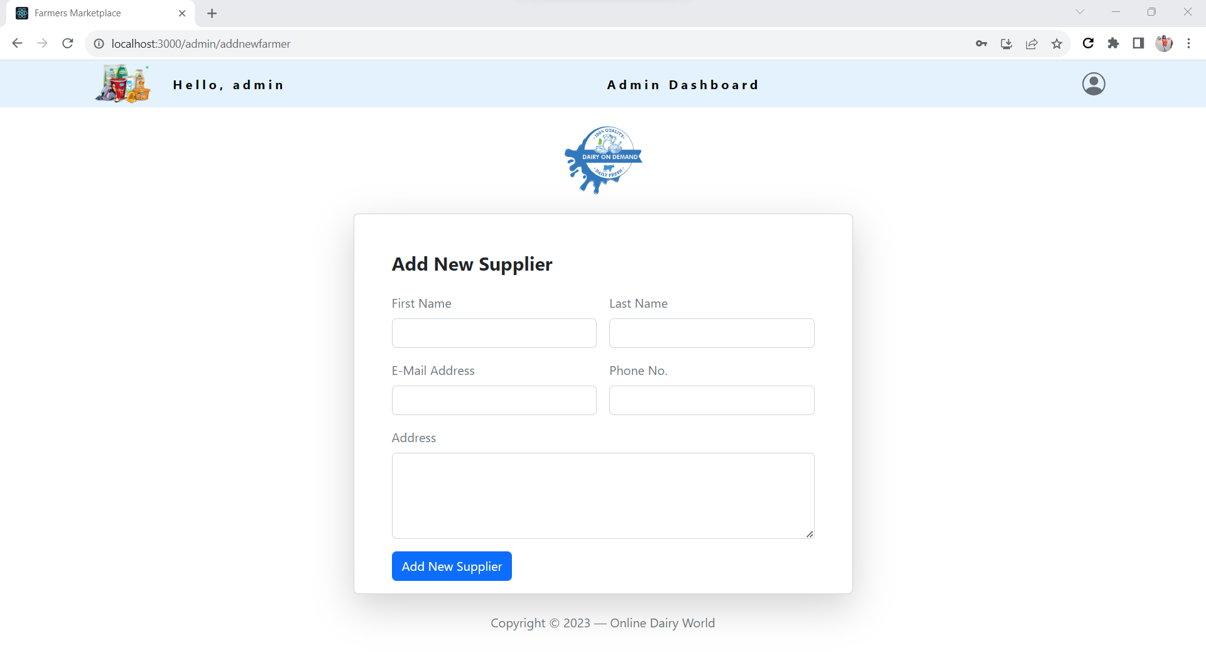

**8.3.4 Form for add new Category.**

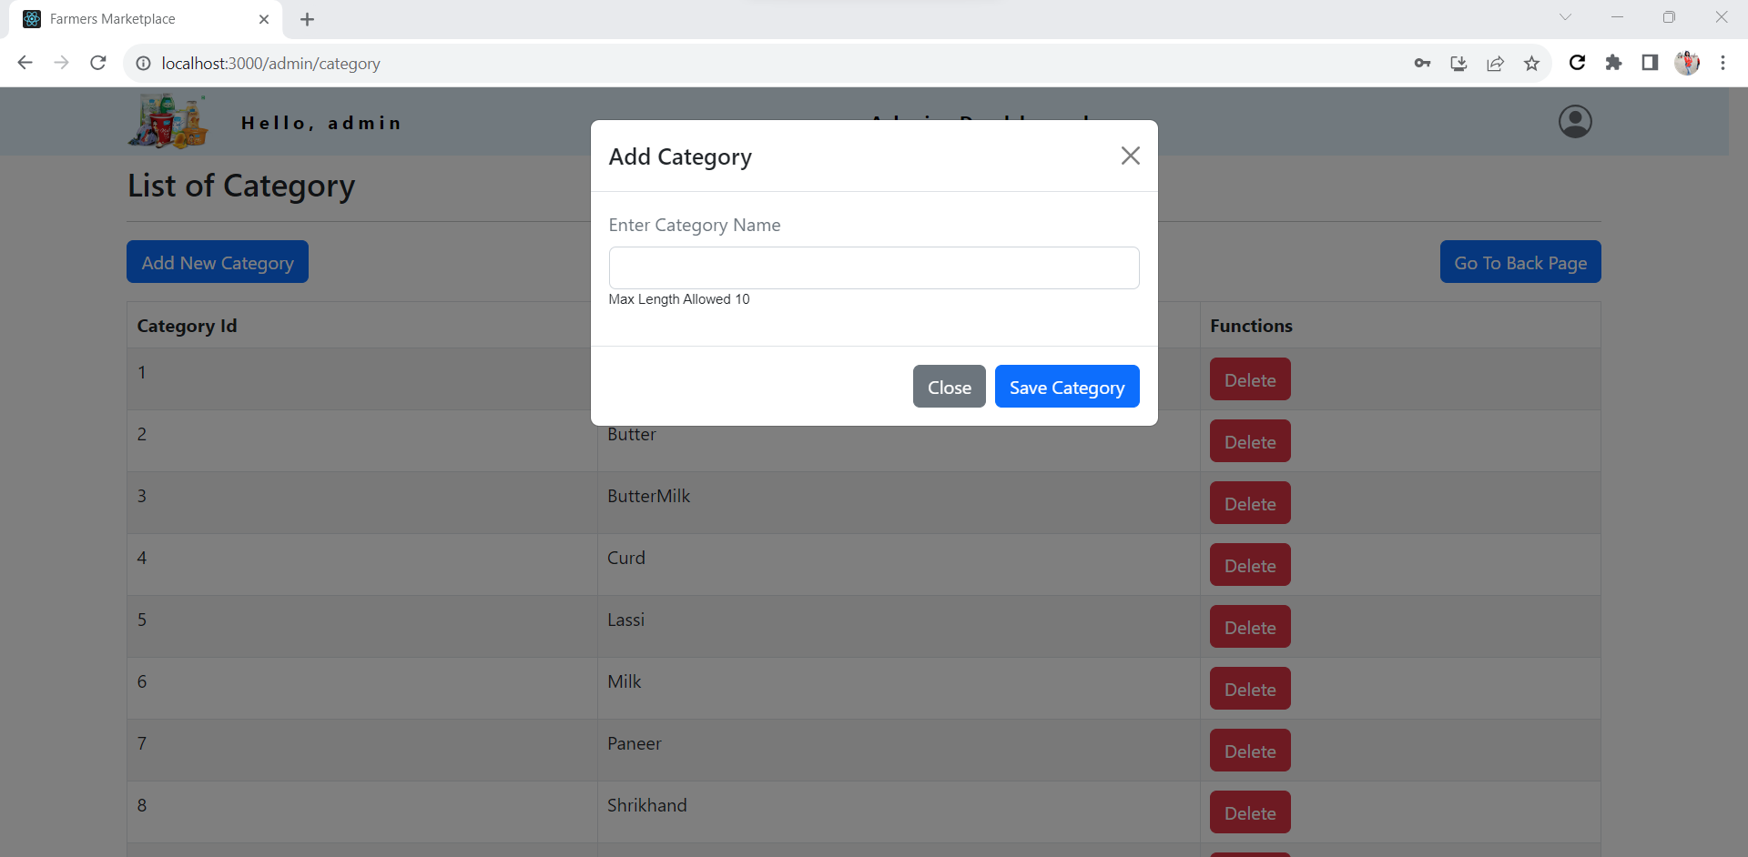

**8.3.5 List of all products**

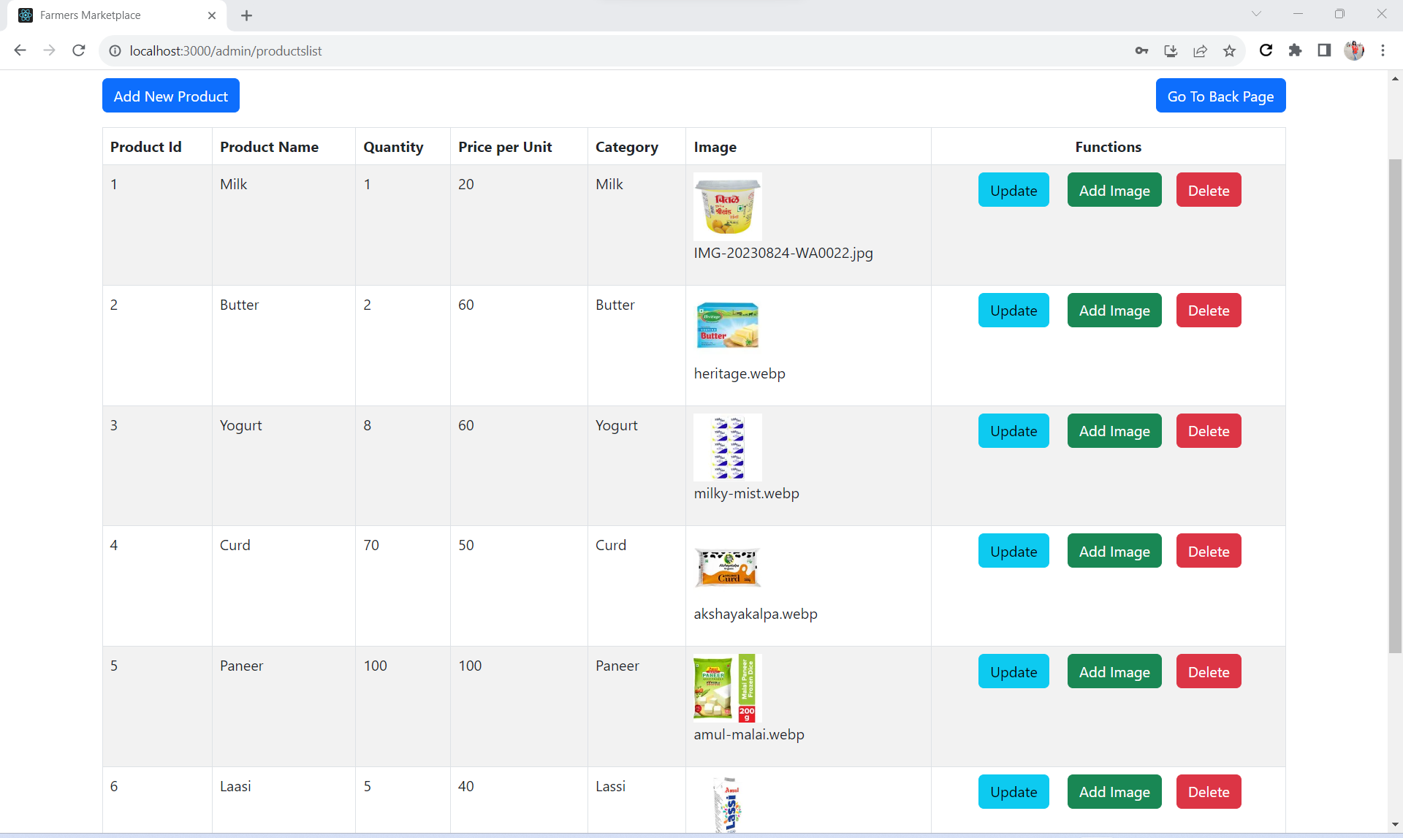

**8.3.6 Add New Product**

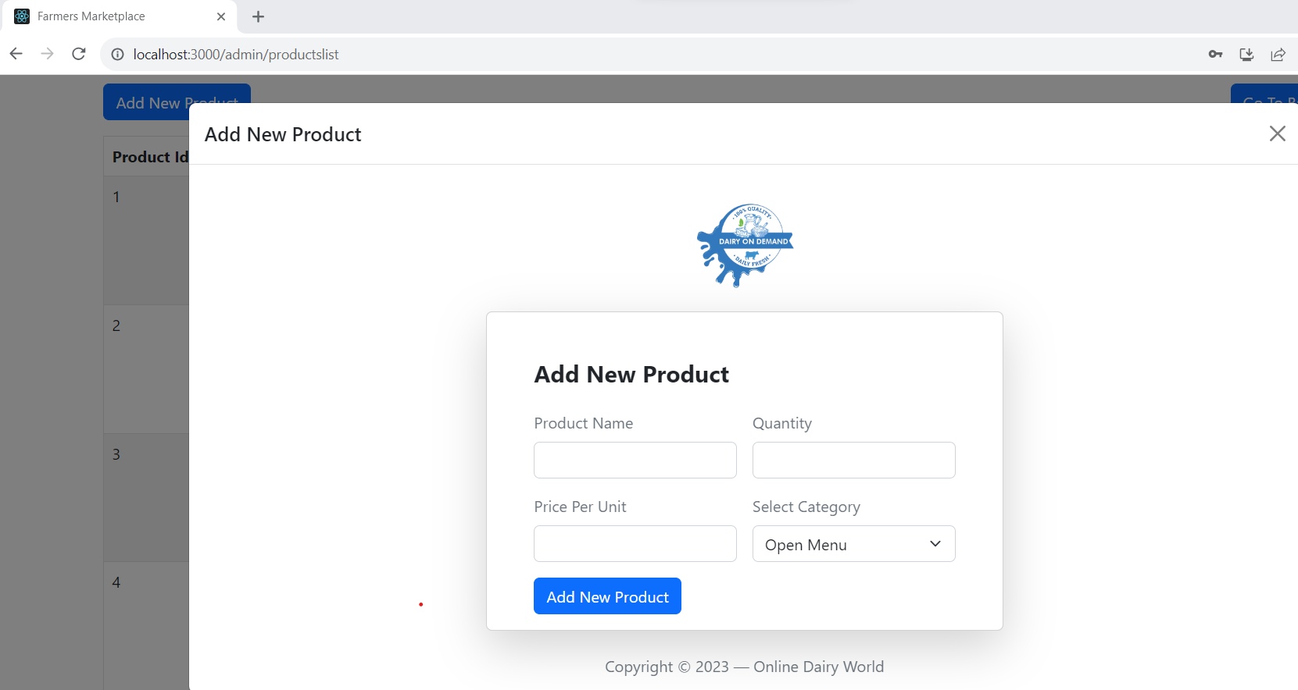

**8.3.7 List of Order Details**

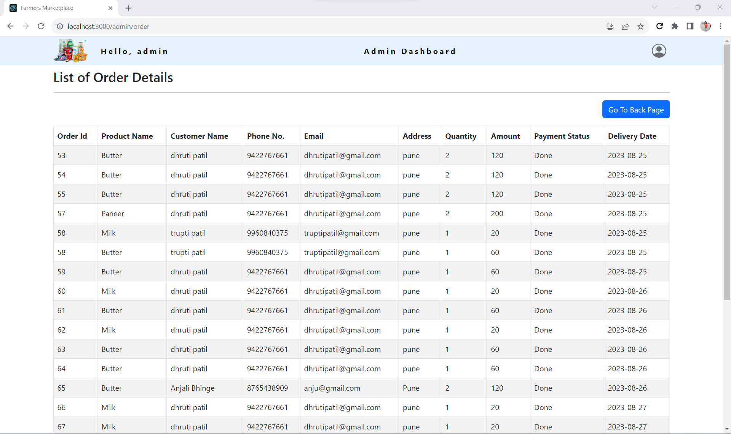

**8.3.8 List of Users Details**

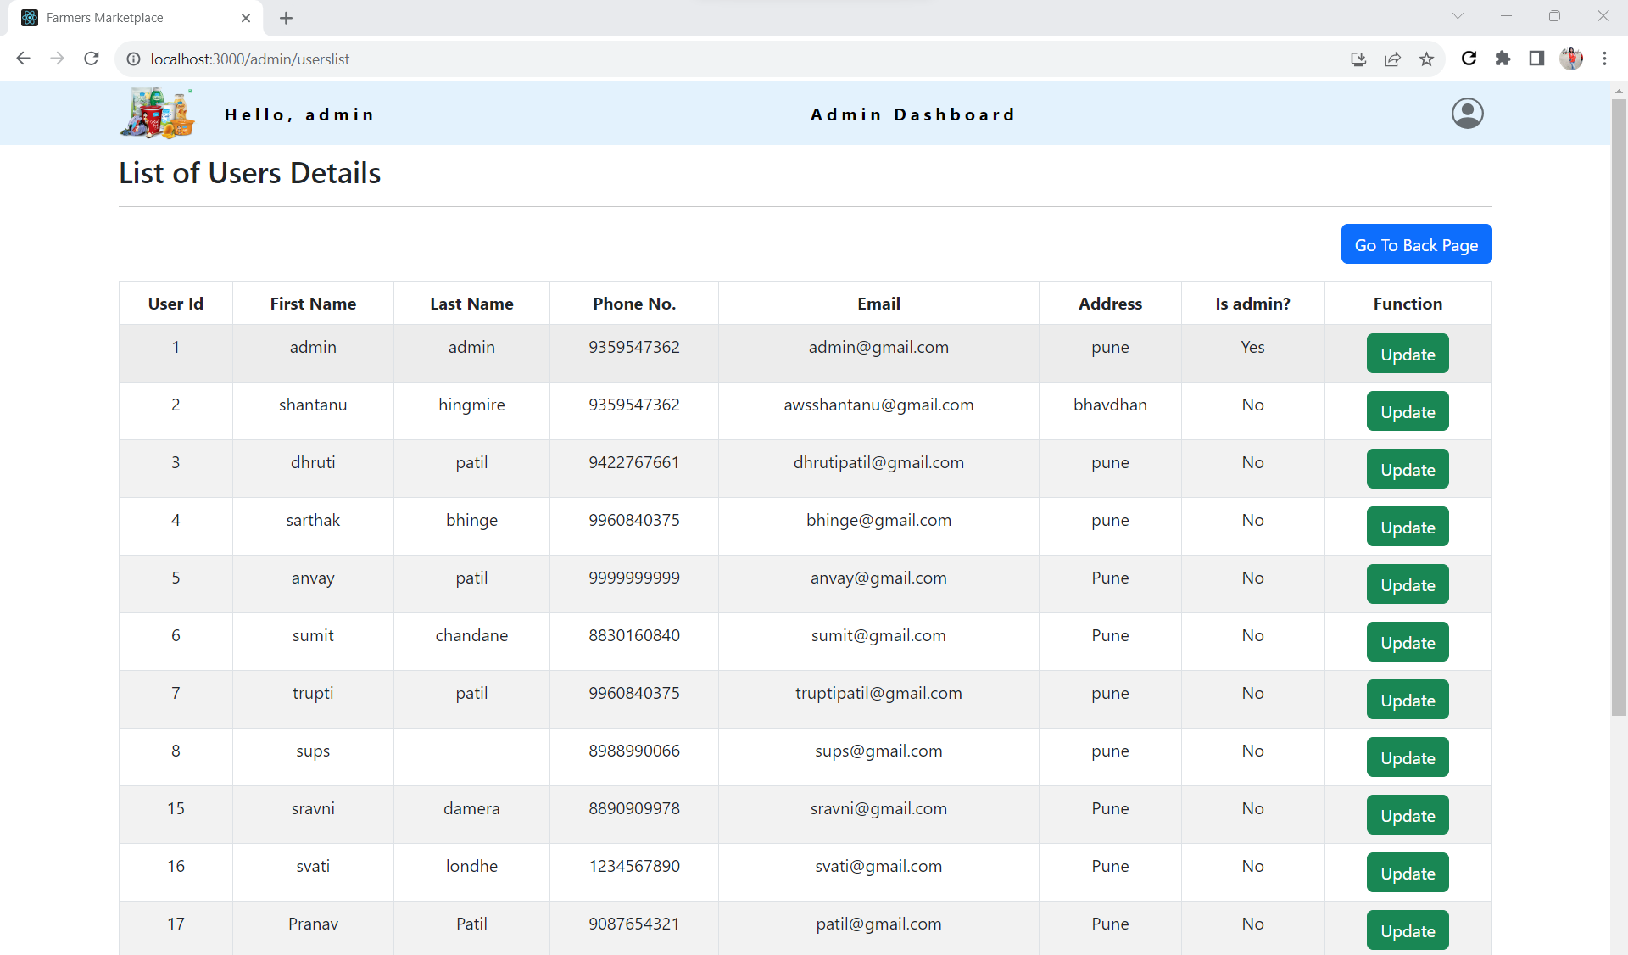

**8.4 Buyer Login**

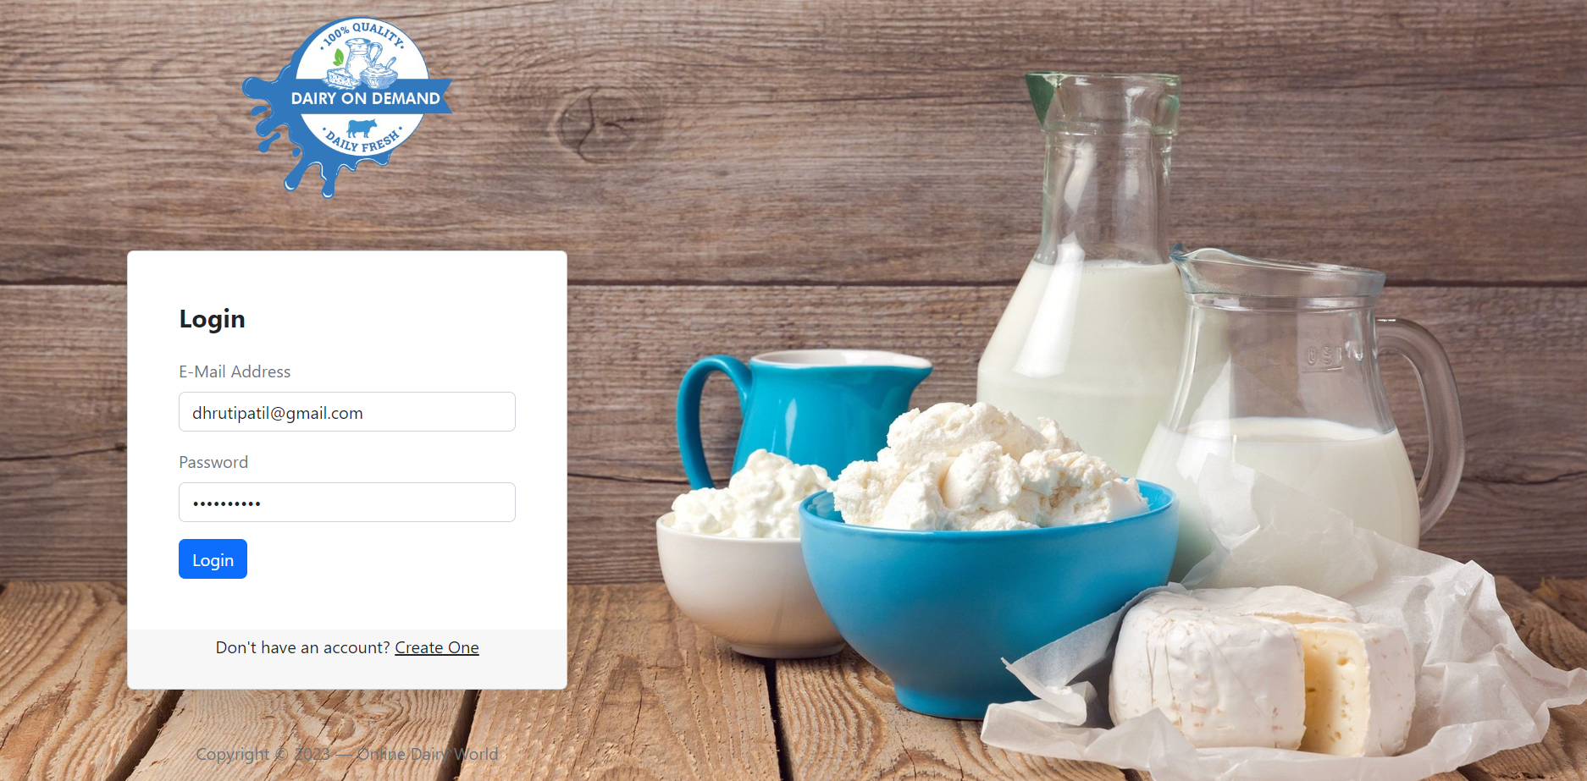

**8.4.1 List of Dairy Products**

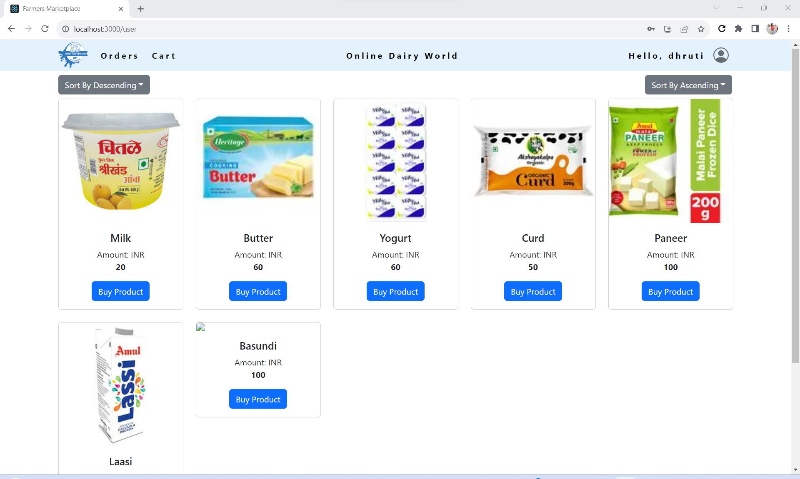

**8.4.2 Searching the products by priceascending,quantity ascending,name ascending.**

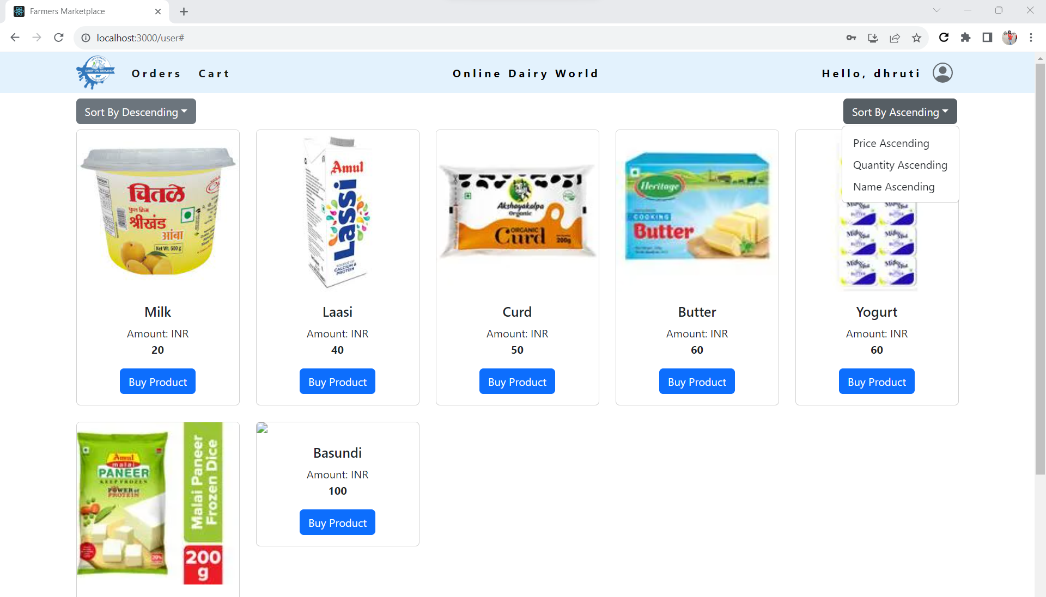

**8.4.3 Add to cart product**

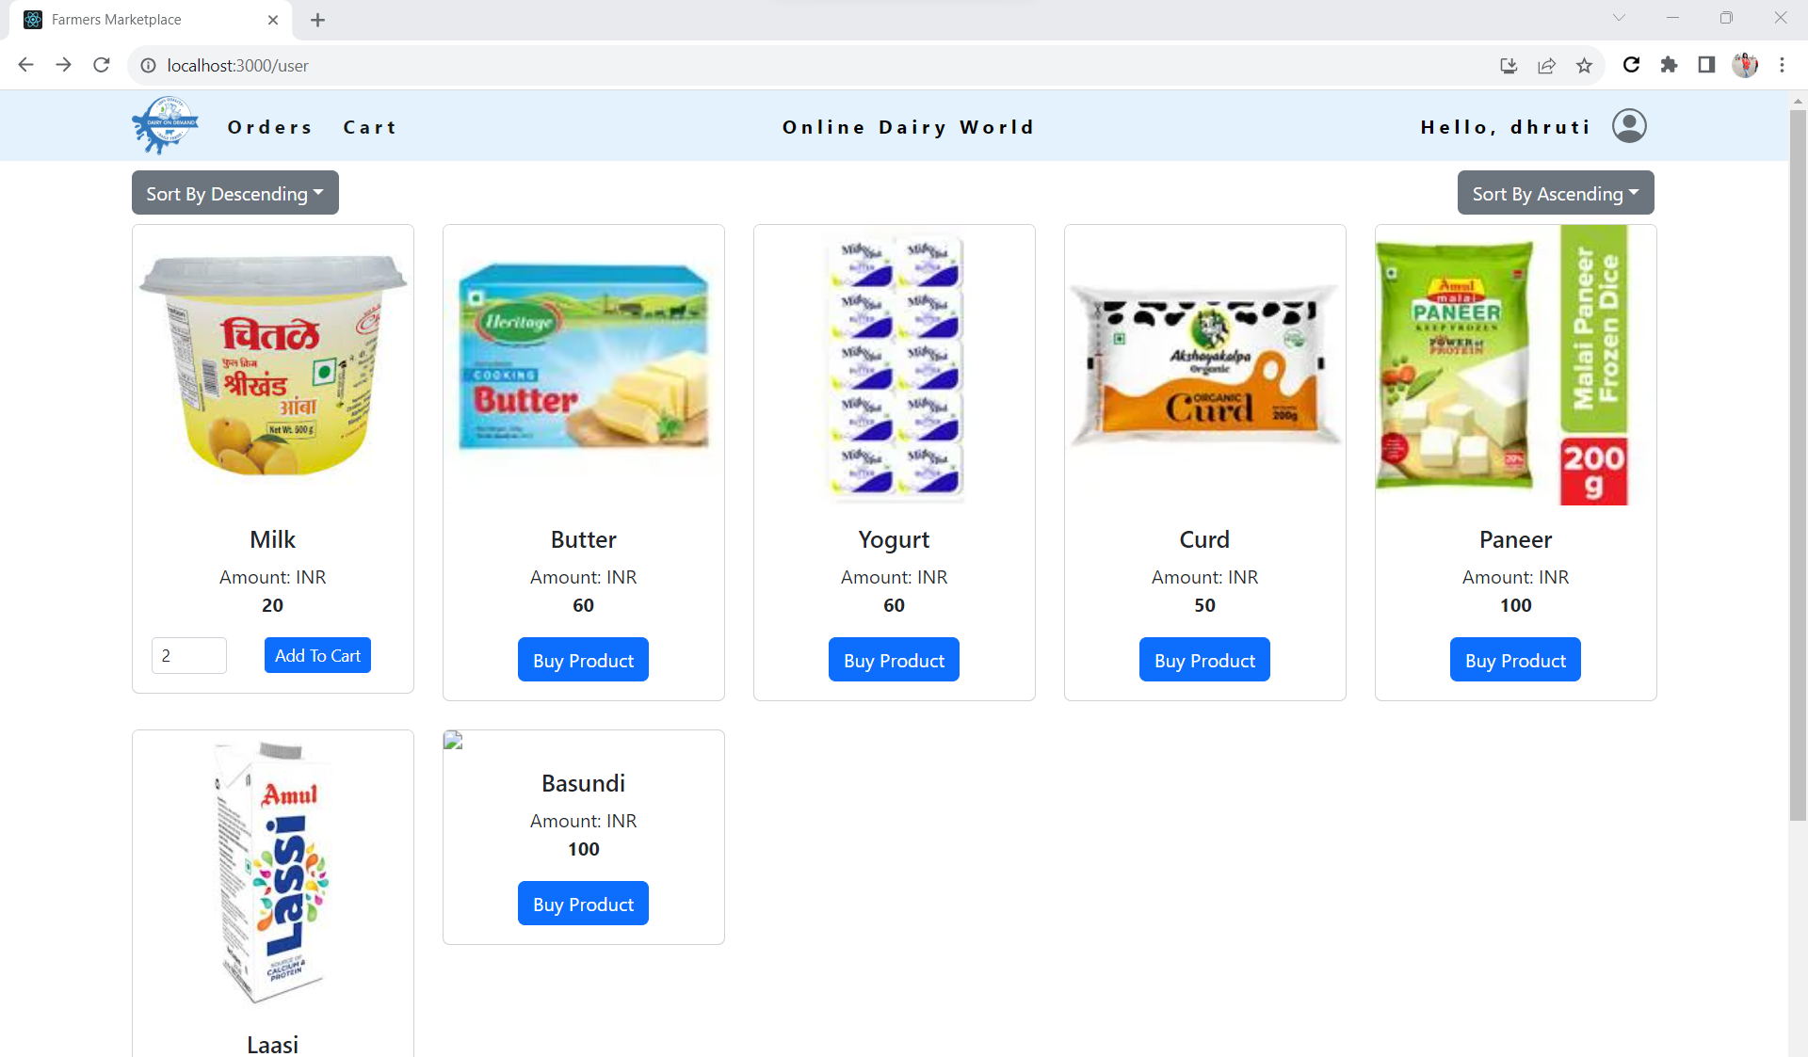

**8.4.3 Product added into the Cart and Place the order**

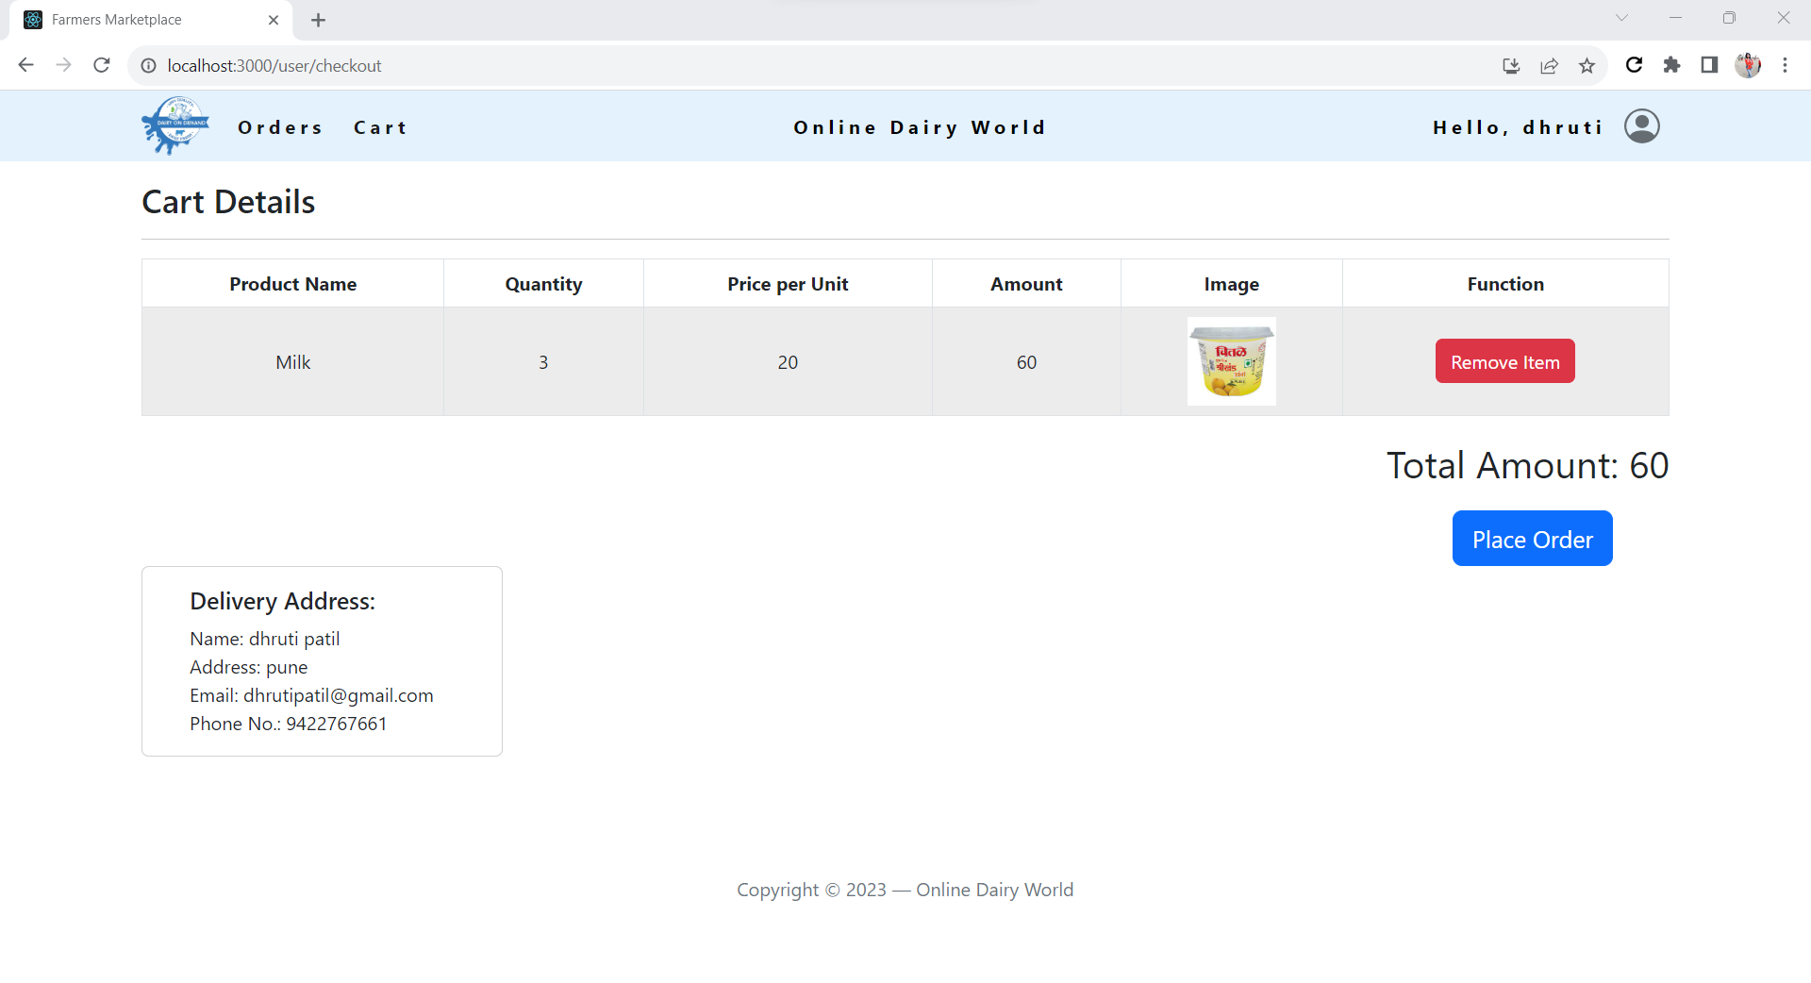

**8.4.3 Make the Payement**

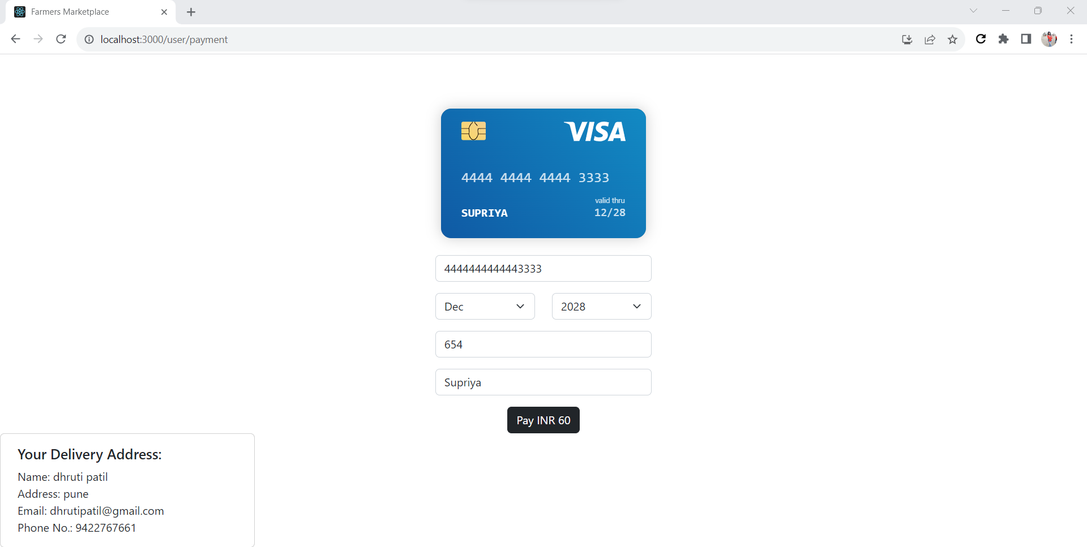

**8.4.3 Order Details**

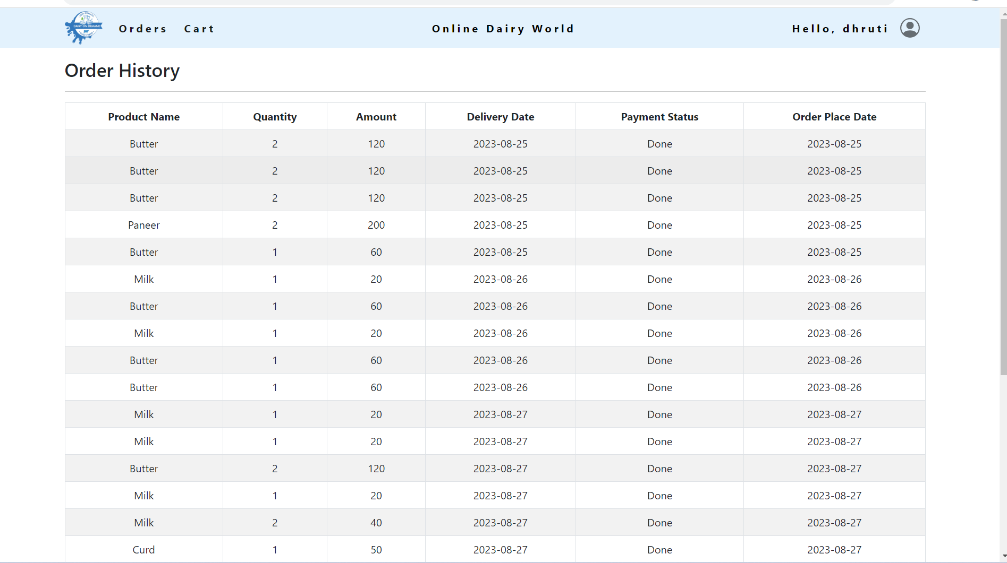

**9. CONCLUSION AND FUTURE SCOPE**

* Customers can seamlessly browse through products and place order.
* Customers can select many variety of products to cart such as milk ,cheese, ghee, yogurt, butter and more of various brands .
* Online dairy world website bridge the gap between suppliers and buyers in digital way.
* **Expansion of Product Range:** As the website gains popularity and consumer trust, you can consider expanding the range of dairy products offered, including specialty and organic options.
* **Personalized Recommendations:** Implementing AI-driven algorithms can provide personalized product recommendations based on user preferences and purchase history, enhancing the user experience.
* **Subscription Models:** Introducing subscription plans for regular dairy deliveries can create a loyal customer base and ensure a steady revenue stream.
* **Payment Gateway:** Providing real time transaction in website